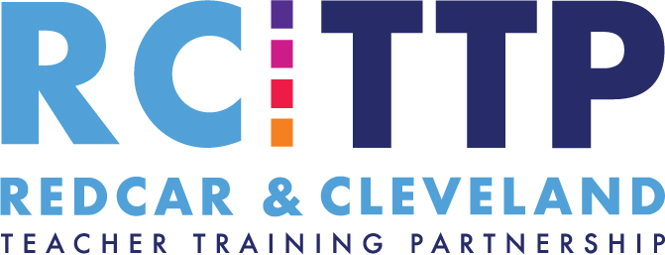 Risk Management, Fraud, Bribery and Whistle Blowing Policy
RCTTP comes under the umbrella of Redcar and Cleveland Borough Council for all matters relating to risk management, fraud, bribery and whistleblowing. In the case of issues arising to these matters we would refer to the council policy and the appropriate appointed officer. School partners should adhere to polices in their own schools.

The policy and procedure are available to all members of staff through the Council Intranet. An electronic copy of the policy is also stored centrally.

- RCTTP Risk Assessment Matrix and RCBC Risk Management Policy (Appendix 11a)
- RCBC Insurance Manual and Certificate of Employers’ Liability Insurance (Appendix 11b)
- RCBC Fraud, Bribery and Corruption policy (Appendix 11c)
- RCBC Whistleblowing Policy (Appendix 11d)
- RCBC Anti-Money Laundering Policy (Appendix 11e)

